# **Product Requirements Document (PRD)**

## 

## **Disney+ Hotstar Watchlist Feature**

### **1. Introduction**

The **Watchlist** feature is an essential functionality designed to provide users with a convenient and personalized way to manage their entertainment choices effectively. This feature allows users to create, maintain, and organize a curated list of movies, TV shows, or other media content that they wish to watch at a later time. By offering a seamless and user-friendly interface, the Watchlist ensures that users never lose track of interesting content, making it easier to revisit and access their preferred selections whenever they choose.

The primary objective of the Watchlist feature is to enhance user engagement, improve content retention, and provide a structured approach to content discovery. Users can effortlessly browse through vast libraries of movies and TV series, bookmark their selections, and retrieve them at their convenience. This functionality is particularly beneficial for users who come across intriguing titles but may not have the time to watch them immediately.

In addition to its fundamental bookmarking capability, the Watchlist feature may include supplementary enhancements such as categorization, tagging, sorting, and filtering options, allowing users to refine and organize their saved content based on genres, release dates, popularity, or personal preferences. Furthermore, some implementations of the Watchlist feature may integrate recommendations based on a user's saved content, helping them discover similar movies and TV shows tailored to their interests.

By streamlining the content discovery and saving process, the Watchlist feature contributes to increased user satisfaction and retention. It encourages users to return to the platform, ensuring a more engaging and personalized viewing experience.

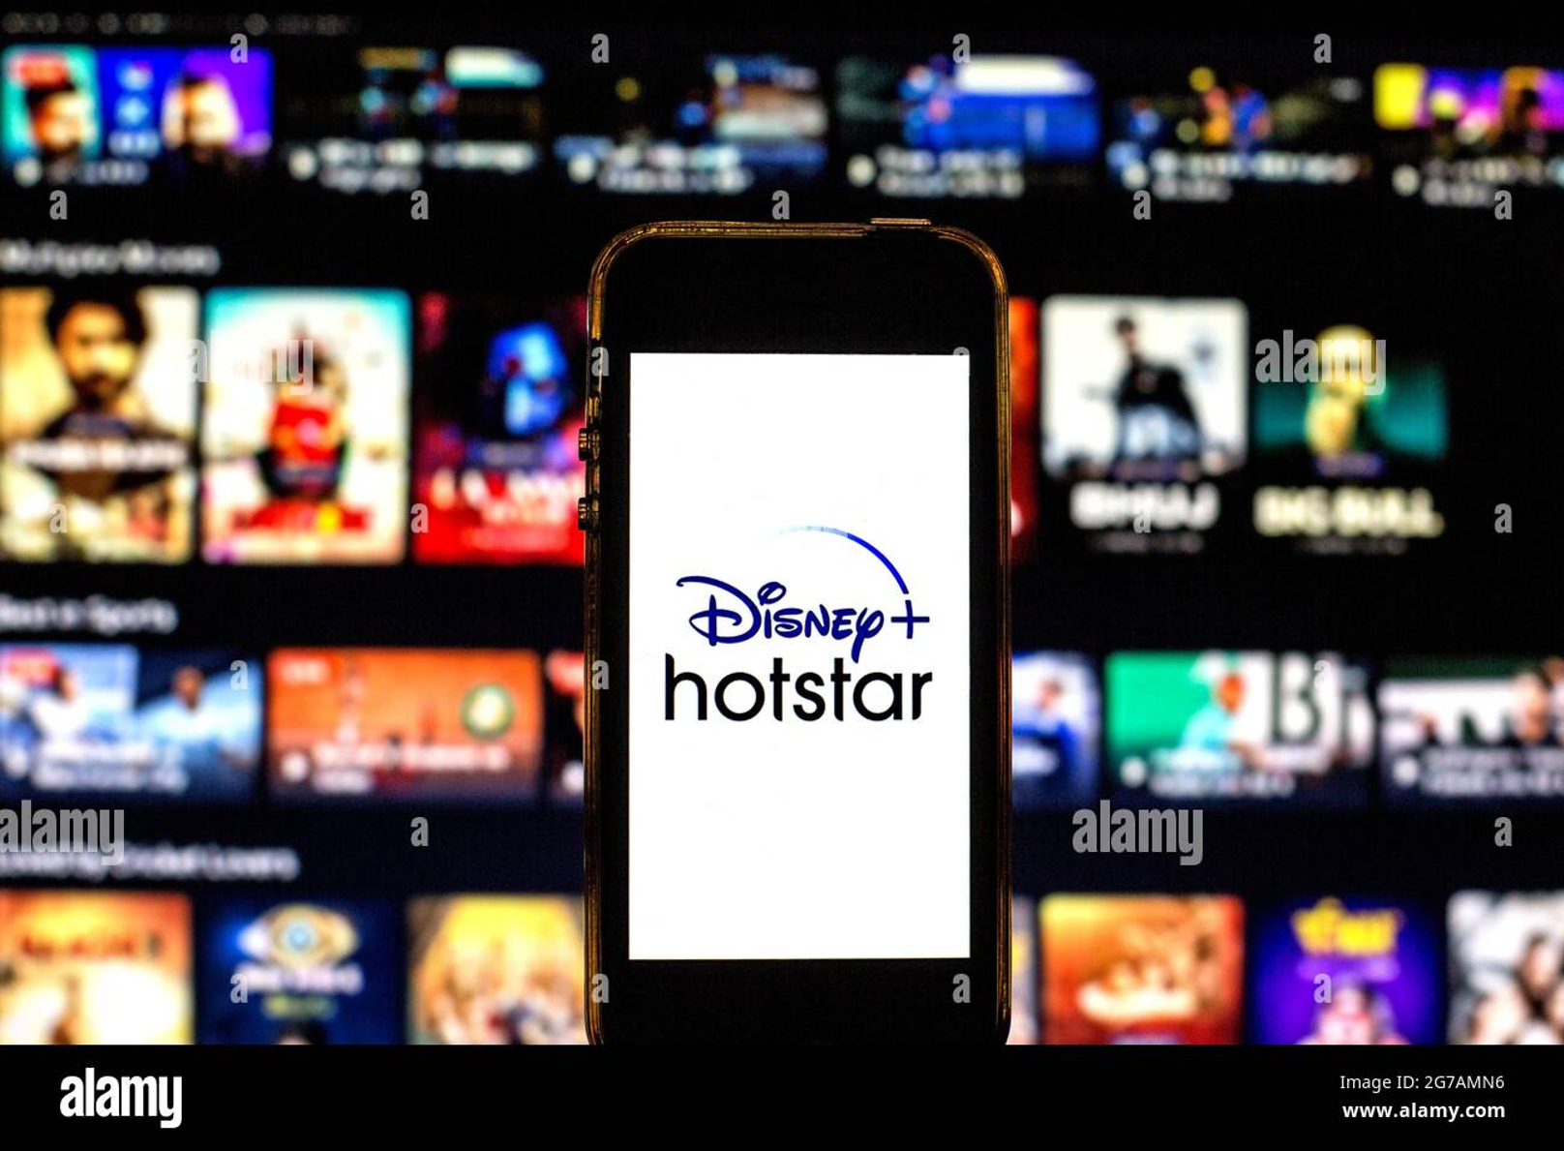

### **2. Objectives**

### The Watchlist feature is designed with the following key objectives to enhance the overall user experience, improve content accessibility, and drive higher engagement on the platform:

### Enable Users to Add, Remove, and Manage Their Watchlist Efficiently

### Users should have the ability to seamlessly add movies, TV shows, and other media content to their personalized Watchlist with a single tap or click.

### The feature should allow for easy removal of items from the Watchlist once they have been watched or are no longer of interest.

### Users should be able to manage their Watchlist effectively by rearranging items, categorizing content based on preferences, and applying sorting or filtering options for better organization.

### Ensure Easy and Seamless Access to Saved Content Across Multiple Devices

### The Watchlist should be accessible across different devices, including smartphones, tablets, smart TVs, and desktop platforms, ensuring a synchronized and unified experience.

### Users should be able to log into their accounts and retrieve their saved content instantly, regardless of the device they are using.

### Cloud-based synchronization should be implemented to ensure real-time updates so that changes made on one device reflect across all others without delays.

### Enhance Content Discoverability and Encourage Ongoing Platform Engagement

### The Watchlist should play a key role in improving content discoverability by providing users with a structured way to save and revisit interesting movies and TV shows.

### The feature should integrate with recommendation engines, suggesting relevant content based on a user’s saved list, previously watched items, and overall viewing habits.

### By keeping users engaged with their saved content, the Watchlist should contribute to increased time spent on the platform, higher retention rates, and continued subscription or usage.

### 



### **3. Key Features**

#### **3.1. Add to Watchlist**

The **Add to Watchlist** functionality is designed to provide users with a simple and intuitive way to save content for future viewing. This feature ensures that users can easily bookmark their favorite movies, TV shows, and live sports events, enabling them to quickly access their selections whenever they want.

* Users can add content to their Watchlist directly from the **content detail page**, ensuring a smooth and hassle-free experience.
* A **"+ Watchlist" button** is prominently displayed on each content card, making it easy for users to add an item to their list with a single tap or click.
* Upon adding content, users may receive a **confirmation message or animation**, providing visual feedback that the item has been successfully saved.
* The system may include a **hover or tooltip feature** displaying a brief description of what adding content to the Watchlist entails, improving user awareness.
* Items that are already added to the Watchlist will have the "+ Watchlist" button dynamically change to **"Added" or "In Watchlist"**, preventing duplicate additions and improving clarity.
* If users are not logged in, they may be prompted to **sign in or create an account** to enable Watchlist functionality and ensure their selections are stored across sessions and devices.
* The feature may also support adding content from **various browsing sections**, including trending lists, search results, and recommendation carousels, increasing accessibility and convenience.

This functionality forms the foundation of the Watchlist feature, allowing users to curate a personalized library of content, enhancing their content discovery experience, and ensuring they never lose track of what they want to watch.

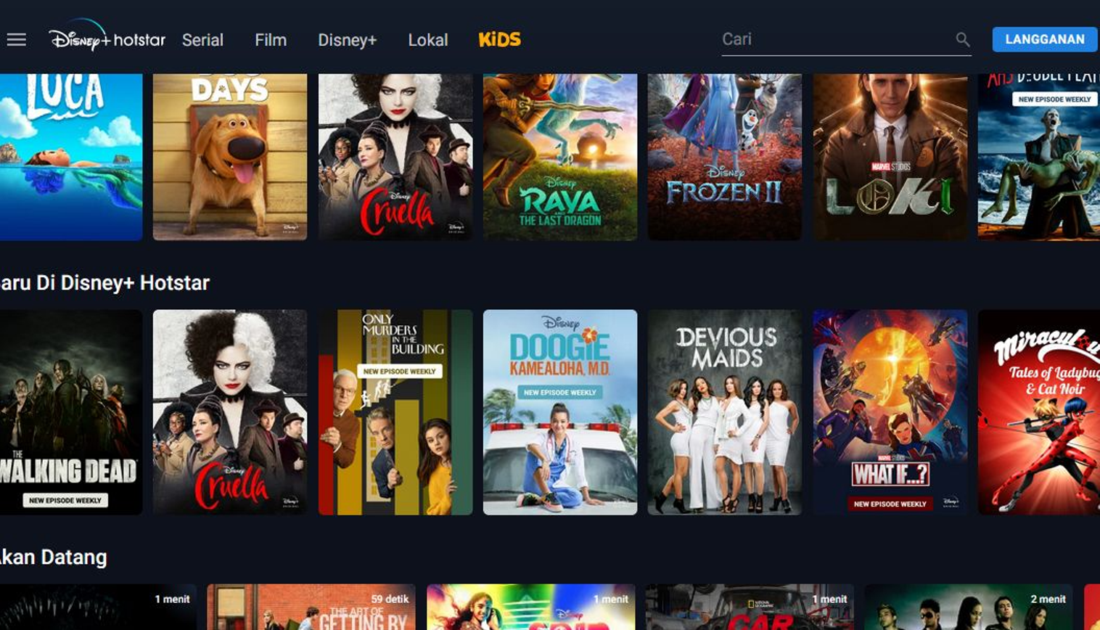

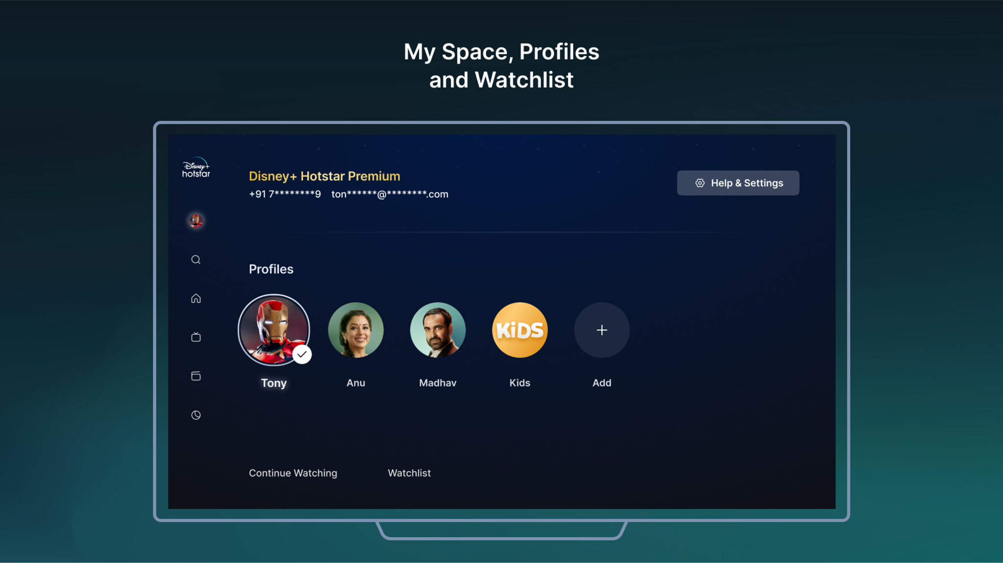

#### **3.2. Remove from Watchlist**

#### The Remove from Watchlist functionality ensures that users have complete control over their curated content list, allowing them to effortlessly manage and update their Watchlist based on their viewing preferences.

#### Users can remove content from their Watchlist by clicking the "Remove" button, which is available within both the Watchlist page and the content detail page.

#### When a user removes an item, the system provides instant visual feedback, such as:

#### A confirmation message (e.g., "Removed from Watchlist").

#### A subtle animation or fade effect to indicate successful removal.

#### The Watchlist button dynamically updates—once an item is removed, it reverts to the original "+ Watchlist" state, allowing users to re-add it if needed.

#### For enhanced user experience, a "Undo" option may appear immediately after removal, giving users a brief window to reverse accidental deletions.

#### Users can remove multiple items efficiently by accessing their Watchlist and using:

#### Swipe-to-remove gestures (on mobile devices).

#### Bulk selection and removal options (for better management of large Watchlists).

#### If the content is removed successfully, it will no longer appear in the user's Watchlist across all synced devices.

#### Platforms with voice control support (such as smart TVs or voice assistants) may allow users to remove content via voice commands, further enhancing accessibility.

#### 

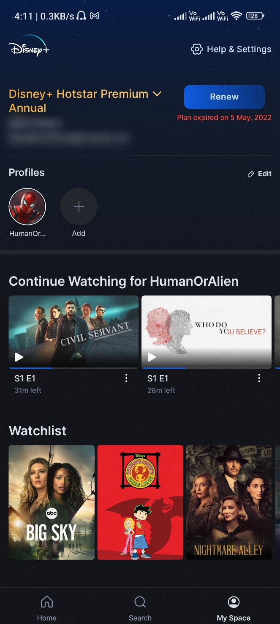

#### **3.3. Accessing the Watchlist**

#### The Watchlist is designed to be easily accessible across multiple sections of the platform, ensuring that users can quickly locate and manage their saved content without hassle.

#### The Watchlist is available under the user profile section, allowing users to navigate to their saved content from their account settings on both the app and website.

#### Additionally, a dedicated Watchlist tab is prominently featured in the app and website navigation menu, providing a direct and seamless entry point for users.

#### Users can access their Watchlist across multiple devices, including smartphones, tablets, desktops, and smart TVs, ensuring a consistent and synchronized experience.

#### The Watchlist interface is designed for quick browsing and management, featuring:

#### A grid or list view for different browsing preferences.

#### Thumbnail previews for visual identification of saved content.

#### Playback progress indicators, if applicable, to show partially watched content.

#### Sorting and Filtering Options

#### To enhance usability, users can refine their Watchlist using sorting and filtering functionalities, making it easier to locate specific content:

#### Sorting options include:

#### Recently Added: Displays the most recently saved content at the top.

#### Alphabetical Order: Organizes content in A-Z or Z-A order.

#### Release Date: Sorts content based on its original release year.

#### Most Watched: Prioritizes content that has been frequently accessed.

#### Filtering options allow users to narrow down content based on:

#### Genres (e.g., Action, Comedy, Drama, Thriller).

#### Content Type (Movies, TV Shows, Sports Events).

#### Watch Status (Watched, Unwatched, In Progress).

#### 

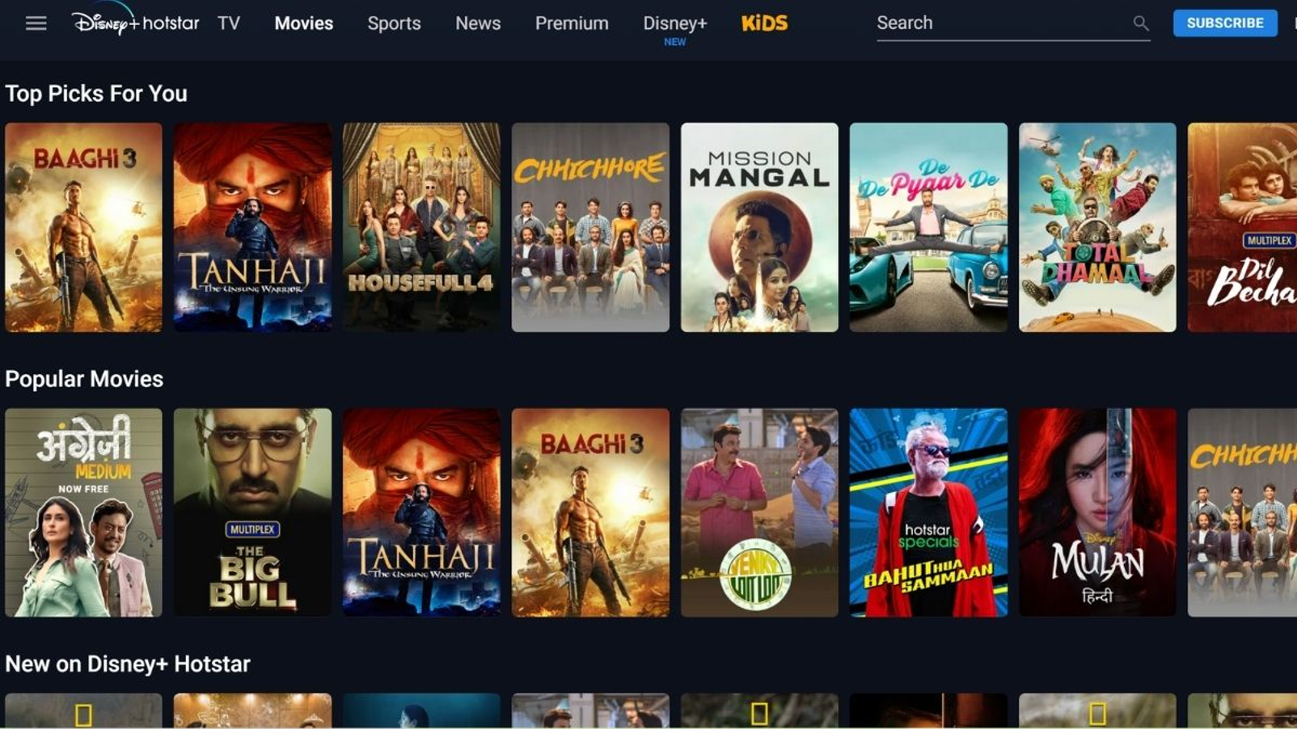

#### **3.4. 3.4. Sync Across Devices**

#### The Sync Across Devices functionality ensures that users can seamlessly access and manage their Watchlist across multiple platforms, maintaining a consistent and uninterrupted viewing experience.

#### The Watchlist is linked to the user’s account, meaning all saved content is securely stored in the cloud rather than being device-specific.

#### Users can access their synced Watchlist from various devices, including:

#### Smartphones and Tablets (iOS and Android apps).

#### Desktops and Laptops (via the website or web app).

#### Smart TVs and Streaming Devices (such as Apple TV, Android TV, Firestick, Roku).

#### Any updates made to the Watchlist—such as adding or removing content—are instantly reflected across all connected devices, ensuring real-time synchronization.

#### If a user starts watching a movie or TV show on one device, the Watchlist may display a playback progress indicator, allowing them to resume from where they left off on another device.

#### Users signing into a new device will have immediate access to their existing Watchlist, provided they log in with the same account credentials.

#### In cases where a device is offline, changes made to the Watchlist will sync automatically once an internet connection is restored.

#### Platforms that support multiple user profiles (such as family accounts) will ensure that each profile maintains a separate Watchlist, preventing content overlap between users.

#### 

#### **3.5. Watchlist Notifications**

#### The feature enhances user engagement by providing timely reminders about saved content, ensuring that users do not forget about movies, TV shows, or sports events they intended to watch.

#### Unwatched Content Reminders:

#### Users can receive optional notifications reminding them of movies or TV shows that have been in their Watchlist for an extended period but have not been watched.

#### Notifications may be sent based on user preferences, such as weekly or monthly reminders about unwatched content.

#### Expiring Content Alerts:

#### If content in the Watchlist is set to expire or leave the platform soon, users will receive an alert, giving them time to watch it before it becomes unavailable.

#### These notifications can include details like the expiration date and a direct link to start watching.

#### Customization & User Preferences:

#### Users have the flexibility to enable, disable, or customize notification settings through the Watchlist settings menu.

#### Options may include:

#### Reminder Frequency: Choose between daily, weekly, or monthly notifications.

#### Notification Type: Enable only specific types of alerts (e.g., expiring content but not unwatched reminders).

#### Do Not Disturb Mode: Temporarily mute notifications during certain hours.

#### Delivery Methods:

#### Notifications may be sent via:

#### Push notifications on mobile devices and tablets.

#### Email alerts for users who prefer inbox reminders.

#### In-app notifications when browsing the platform.

#### 

### **4. User Flow**

The Watchlist feature follows a **simple and intuitive user flow**, ensuring that users can efficiently discover, save, and manage their favorite content on **Disney+ Hotstar**. Below is a step-by-step breakdown of the process:

#### **Step 1: User Logs into Their Disney+ Hotstar Account**

* The user opens the **Disney+ Hotstar** app or website.
* They sign in using their credentials (email, phone number, or social media login).
* Once logged in, their personalized content recommendations and previously saved Watchlist are accessible.



#### **Step 2: User Searches or Browses for a Movie/Show**

* The user **browses different sections**, such as:
  + Featured movies and TV shows.
  + Genre-based categories (e.g., Action, Comedy, Drama).
  + Trending, recommended, or newly added content.
* Alternatively, they **use the search bar** to find specific movies, TV shows, or live sports events.



#### **Step 3: User Clicks "+ Watchlist" to Save Content**

* On the **content detail page**, the user sees a **"+ Watchlist" button** prominently displayed.
* Clicking the button instantly adds the content to their **personal Watchlist**.
* A **confirmation message or animation** appears to indicate a successful addition.
* The button updates dynamically to **"Added" or "In Watchlist"**, preventing duplicate saves.



#### **Step 4: User Accesses Their Watchlist from Their Profile**

* The user navigates to their **profile section** or taps on the **dedicated Watchlist tab** available in the app or website.
* Inside the Watchlist, content is displayed in a **list or grid format** for easy browsing.
* Users can **sort and filter** their Watchlist based on genre, release date, or watch status.

#### **Step 5: User Watches or Removes Content from the List**

* When ready to watch, the user clicks on a title in their Watchlist and starts streaming.
* If they no longer want an item in their Watchlist, they:
  + Click the **"Remove"** button on the **Watchlist page** or **content detail page**.
  + Receive a **confirmation message**, with an **optional "Undo"** button to reverse accidental removals.



### **5. Technical Requirements**

The Watchlist feature requires a **robust technical infrastructure** to ensure seamless functionality across different platforms. Below are the key technical components necessary for its implementation:

#### **5.1 Backend**

* A **relational or NoSQL database** to store Watchlist entries, mapped to user accounts.
* Each entry should include:
  + **User ID:** To associate the Watchlist with the correct account.
  + **Content ID:** Unique identifier for each movie, TV show, or event.
  + **Timestamp:** Date and time when the content was added.
  + **Watch Status:** Optional field to track if the user has watched or partially watched the content.
* Backend logic to **handle read/write operations** for Watchlist items.
* Caching mechanisms (e.g., **Redis**) to enhance performance and reduce database load.

#### **5.2 Frontend**

* UI elements to allow users to interact with their Watchlist, including:
  + **"+ Watchlist" button** on content cards and detail pages.
  + **"Remove" button** to delete content from the Watchlist.
  + **Watchlist page/tab** with sortable and filterable lists.
* **Dynamic UI updates** to reflect changes in real-time (e.g., toggling the Watchlist button state).
* Responsive design to ensure usability across different screen sizes and devices.

#### **5.3 APIs**

* RESTful or GraphQL API endpoints to support Watchlist functionality:
  + **POST /watchlist/add** – Adds a movie or TV show to the user's Watchlist.
  + **GET /watchlist** – Retrieves the user's Watchlist with filtering and sorting options.
  + **DELETE /watchlist/remove** – Removes a selected item from the Watchlist.
  + **PATCH /watchlist/update** – Updates metadata (e.g., watch status, sorting order).
* API security measures, including **authentication (OAuth, JWT)** and **rate limiting** to prevent abuse.

#### **5.4 Cross-Platform Compatibility**

* The Watchlist must be synchronized across **mobile apps, web, and Smart TVs** via cloud storage and API-based sync mechanisms.
* **Device synchronization considerations:**
  + **Mobile (iOS/Android apps):** Watchlist stored in a user account and fetched dynamically.
  + **Web application:** Persistent session-based access to the Watchlist via API calls.
  + **Smart TVs & Streaming Devices:** Optimized UI for remote navigation and voice control support.
* Offline support (optional):
  + Allow users to add content to the Watchlist offline and sync changes when reconnected.

### **6. Performance & Scalability**

To support a large-scale user base and ensure a smooth experience, the Watchlist feature must be designed with **high performance and scalability** in mind. This includes handling **millions of concurrent users**, optimizing response times, and ensuring minimal latency in data retrieval and synchronization.

#### **6.1 Handling Large-Scale Traffic & Data**

* Implement **horizontal scaling** using cloud-based infrastructure (e.g., AWS, Google Cloud, or Azure) to distribute traffic across multiple servers.
* Use a **load balancer** to manage requests efficiently and prevent server overload.
* Employ **database sharding and indexing** to optimize search and retrieval operations, especially for large user bases.
* Implement **asynchronous processing** for Watchlist updates to avoid blocking critical API operations.

#### **6.2 Optimizing API Calls for Fast Loading Times**

* **Caching strategies:**
  + Use **Redis or Memcached** to store frequently accessed Watchlist data, reducing database queries and improving response speed.
  + Cache Watchlist results at the **edge (CDN caching)** to accelerate data access for users in different geographical regions.
* **Efficient database queries:**
  + Use **indexed queries** to speed up data retrieval.
  + Optimize queries to fetch only the necessary fields, reducing payload size and improving efficiency.
* **Batch processing & pagination:**
  + Implement **pagination** when fetching large Watchlists to avoid excessive data loading at once.
  + Batch API requests to handle multiple Watchlist actions (e.g., bulk adding/removing items) efficiently.
* **Minimizing network latency:**
  + Implement **compressed API responses** (e.g., Gzip) to reduce data transfer size.
  + Use **WebSockets or Server-Sent Events (SSE)** for real-time updates instead of frequent polling.

### **7. Analytics & Metrics**

To measure the effectiveness of the Watchlist feature and optimize user engagement, **key analytics and tracking mechanisms** should be implemented. These insights help assess user behavior, feature adoption, and overall impact on content consumption.

#### **7.1 Key Metrics to Track**

* **Watchlist Engagement Metrics:**
  + **Total Watchlist Additions:** Number of times users add content to their Watchlist.
  + **Total Watchlist Removals:** Frequency of users removing content from their Watchlist.
  + **Active Watchlist Users:** Percentage of users who actively use the feature.
  + **Average Watchlist Size:** The number of items a typical user keeps in their Watchlist.
* **Impact on Watch Time & Content Consumption:**
  + **Watchlist-to-Playback Conversion Rate:** Percentage of Watchlist content that gets watched.
  + **Time from Addition to Playback:** How long content stays in the Watchlist before being watched.
  + **Drop-off Rate:** Percentage of content that remains unwatched in the Watchlist for an extended period.
* **Feature Adoption & User Behavior:**
  + **Watchlist Usage by Device Type:** Breakdown of feature usage across mobile, web, and smart TVs.
  + **Effectiveness of Watchlist Notifications:** How reminders impact content engagement.
  + **User Retention Rates:** Whether Watchlist users exhibit higher retention compared to non-users.

#### **7.2 Tracking & Monitoring Tools**

* **Event Tracking:**
  + Use tools like **Google Analytics, Firebase, or Mixpanel** to track user interactions.
  + Implement **custom event logging** (e.g., “Added to Watchlist,” “Removed from Watchlist,” “Watched from Watchlist”).
  + Utilize **heatmaps and user session recordings** to analyze Watchlist navigation and UI interactions.
* **A/B Testing & Optimization:**
  + Experiment with different **Watchlist button placements, notification strategies, and UI designs** to enhance user engagement.
  + Conduct **A/B tests** to evaluate changes in Watchlist behavior and optimize feature usability.
* **Real-time Monitoring & Alerts:**
  + Use **dashboarding tools** (e.g., Kibana, Grafana, or Datadog) to monitor Watchlist performance.
  + Set up **real-time alerts** for anomalies, such as sudden drops in Watchlist activity or API failures.

### **8. Constraints & Limitations**

While the Watchlist feature is designed to enhance user experience, there are certain **technical and functional constraints** that must be considered.

#### **8.1 Watchlist Size Limitations**

* Each user can add up to **500 items** to their Watchlist.
* Once the limit is reached, users must **remove existing items** before adding new ones.
* To prevent abuse, rate-limiting mechanisms may be implemented, such as:
  + **Daily addition limits** (e.g., a maximum of 50 additions per day).
  + **API rate limits** to prevent excessive requests within a short time frame.

#### **8.2 Offline Availability**

* The Watchlist feature **requires an active internet connection** and does not support offline access.
* Users cannot add, remove, or view their Watchlist in offline mode.
* Any changes made while offline will not be saved and must be reattempted once connectivity is restored.

#### **8.3 Cross-Device Synchronization Delay**

* While the Watchlist syncs across devices in real time, occasional **sync delays** may occur due to:
  + **Network latency** or temporary backend processing delays.
  + **Caching mechanisms** that may cause a short delay in displaying updates.

#### **8.4 Platform-Specific Restrictions**

* Some **smart TVs and older device models** may have a limited Watchlist experience, such as:
  + **No sorting or filtering options** on certain platforms.
  + **Slower sync speeds** compared to mobile or web versions.
  + **Different UI layouts** based on device capabilities.

#### **8.5 Content Availability Limitations**

* Content that **expires or is removed from the platform** will also be automatically removed from users' Watchlists.
* Users will not receive notifications if content is removed due to licensing changes unless explicitly configured.

### **9. Future Enhancements**

To further enhance the Watchlist experience, several advanced features and improvements can be introduced in future updates. These enhancements will **leverage AI, personalization, and social engagement** to make the Watchlist more intuitive and user-friendly.

#### **9.1 Smart Recommendations Based on Watchlist Preferences**

* Use **AI-driven recommendation engines** to suggest content based on the user’s Watchlist.
* Key factors for personalized recommendations:
  + **Genre Preferences:** If a user adds multiple action movies, similar recommendations appear.
  + **Director/Actor Trends:** Suggest movies or shows featuring the same actors or directors from the Watchlist.
  + **Viewing Patterns:** If users frequently watch TV series, recommend similar long-form content.
* **"Because You Added" Section:** Display personalized content recommendations under the Watchlist based on saved items.

#### **9.2 Collaborative Watchlists for Shared Viewing Experiences**

* Introduce **collaborative Watchlists**, allowing users to create **shared Watchlists** with friends or family.
* Features include:
  + **Invite & Share:** Users can invite others to add, remove, or suggest content.
  + **Voting System:** Allow participants to vote on movies or shows to decide what to watch next.
  + **Watch Party Integration:** Sync shared Watchlists with **watch party features** for group streaming.
* Ideal for families, friend groups, or couples looking to curate a list together.

#### **9.3 AI-Based Prioritization of Content in Watchlist**

* **Intelligent Sorting:** Instead of a static list, AI can dynamically adjust the Watchlist based on:
  + **Content Popularity:** Prioritize trending or highly-rated Watchlist content.
  + **Expiring Soon:** Move expiring content to the top for quicker access.
  + **User Interest Levels:** Analyze engagement history to highlight most relevant content.
* **Auto-Reminders Based on Interest:** AI can detect inactivity on specific Watchlist items and send contextual reminders (e.g., “You’ve been adding thrillers—watch this next!”).
* **Predictive Watchlist Optimization:** If users frequently remove similar types of content, AI can recommend better alternatives.

### **10. Conclusion**

The **Watchlist feature** is a **key enhancement** aimed at improving content discovery, user engagement, and platform retention. By offering a **simple yet powerful bookmarking system**, users can conveniently save, manage, and access their favorite content across devices.

With seamless **cross-platform synchronization**, **personalized recommendations**, and potential **AI-driven enhancements**, the Watchlist feature will:

* **Encourage continuous platform usage** by allowing users to save content for later viewing.
* **Improve content discoverability**, ensuring users don’t miss out on shows or movies they are interested in.
* **Enhance user experience** by providing a streamlined and organized way to manage content preferences.

As Disney+ Hotstar continues to innovate, future improvements like **AI-powered prioritization, collaborative Watchlists, and smart recommendations** will further **elevate user engagement**, making the platform a more immersive and enjoyable space for entertainment lovers.